Name:
Period:
Communication
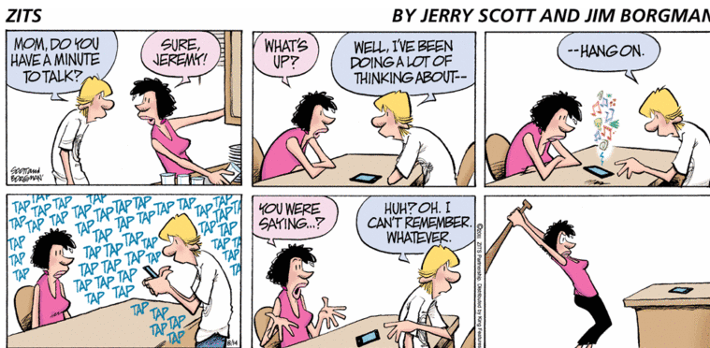

What is communication?

Reflection:
What difficulties did you have when trying to guess the shapes?

How can this relate to communication in families?

What is one strength and one weakness you have as a communicator?

In what ways do we communicate rather than just words?

Can we become confused when someone’s words do not match their body language? Why?

