Decorating the Pillow Squares
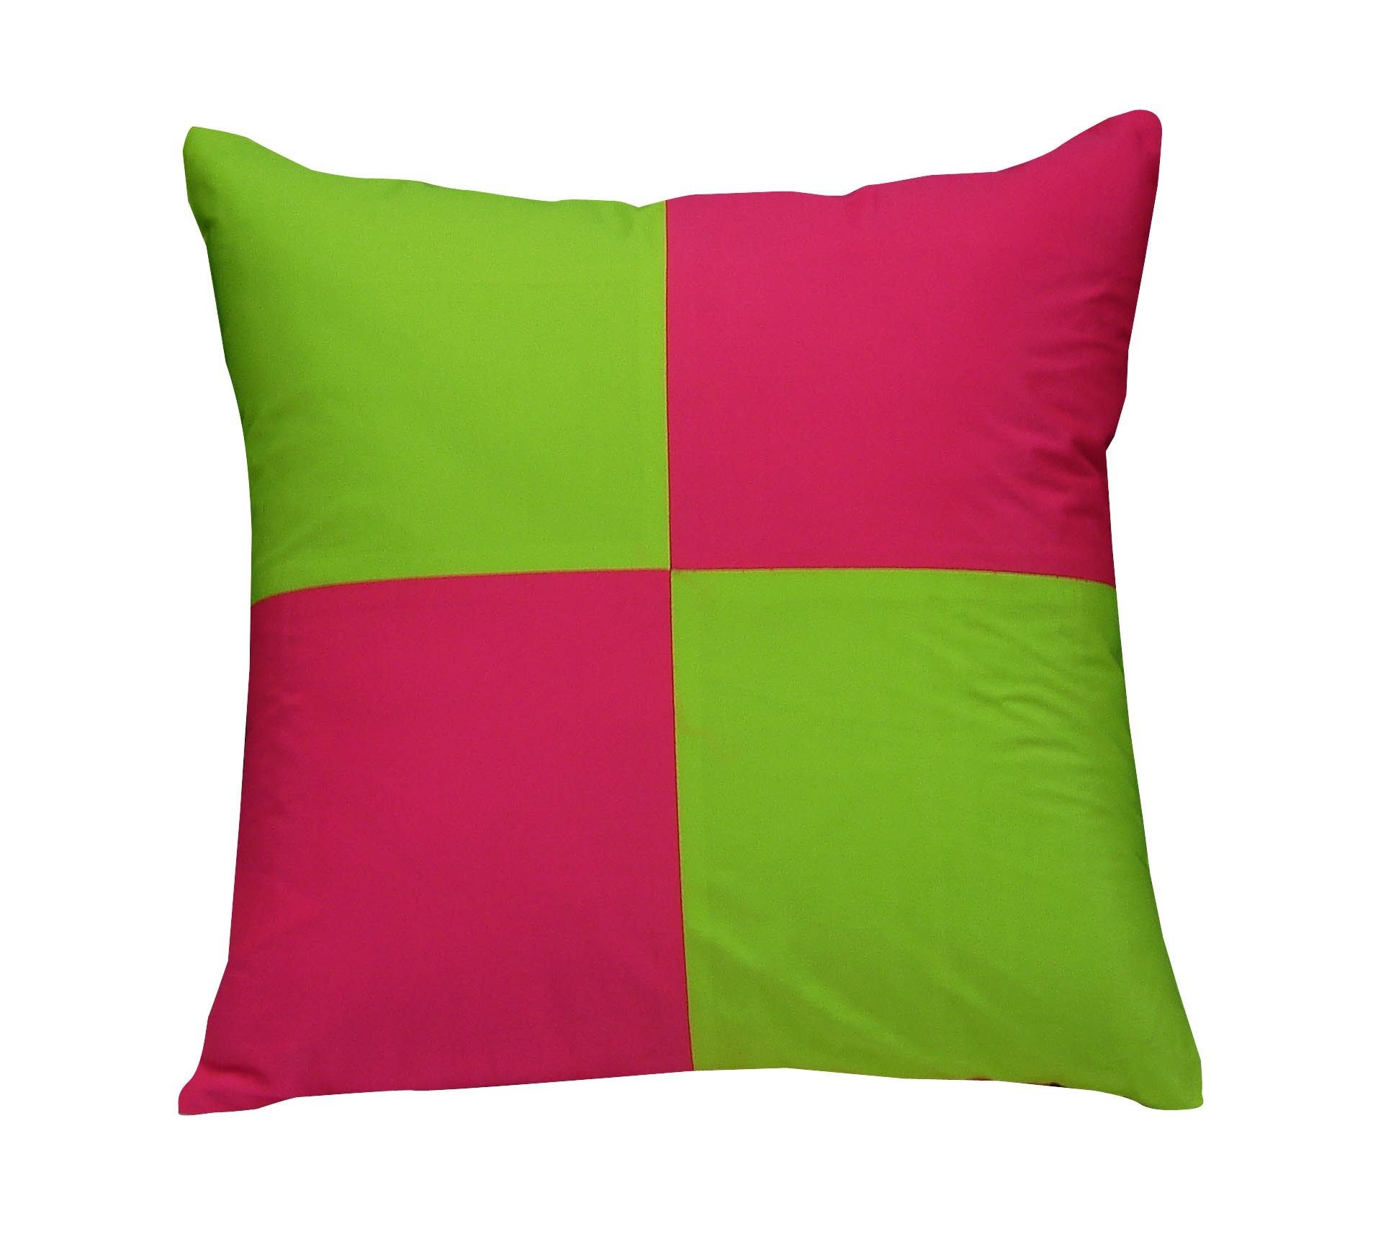
Below are the directions and expectations for what you need to do:
- You get to pick 4 pillow squares. You can choose whatever color(s) you like. If you lose them or wreck them, you need to pay for a new square. They are 50 cents per square.
- You need to decorate at least 2 out of the 4 squares. You can decorate all 4 if you want!
- If you want to use your own fabric you can. Be careful of your fabric choice. It needs to be a thicker fabric. Do not use fleece for your front squares. Ask teacher if you have questions.
- All of the decorating of your pillow must be done at home. You will not have class time to decorate your pillow squares.
- You must have your decorated (but not sewn together) pillow squares returned to school no later than _______________________________________.
- If you want to see examples of past pillows go to face6.weebly.com

Things to remember as you decorate:
- Remember to leave a one-inch margin on all sides. That margin shouldn’t have decorations on them because you won’t see them once it is sewn together.
- Decorate the pillow as an expression of yourself. Think about your favorite things, hobbies, personality traits, or other ideas.
- You can use all sorts of things to decorate your pillow and your family can help you. For example: fabric paint, yarn, beads, thread, iron on, patches, buttons, lace, ribbon, stencils, permanent markers, etc.
- You do not need to go buy supplies. Look to see what you have at home in the craft box!

Pillow Sketching and Rough Draft

Make a rough draft of how you might like to decorate your pillow squares. Label each square with the color you would like it to be. Sketch what designs and/or decorations you would like on your pillow squares.

Make a list below of what things you may need to use in order to decorate your pillow:

