Name:
Period:
FAMILY
What is a FAMILY?

What is a HOME?

What do you like the best about your FAMILY?

What does YOUR FAMILY mean to you?

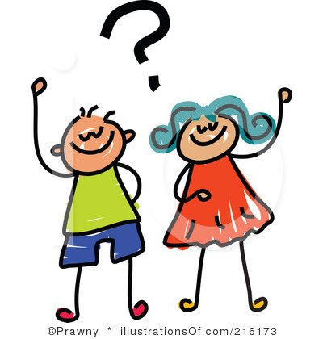
Donut Activity
Below describe what your donut looks like.
___________________________________________________________________________________________________________________________________________________________________________________________________________________________________________________________________________________________________________________________________________________________________________________________________________________________________________________________________________________________________________________________________________________________________________________________________________________________

