**Introduction to Sewing Packet**

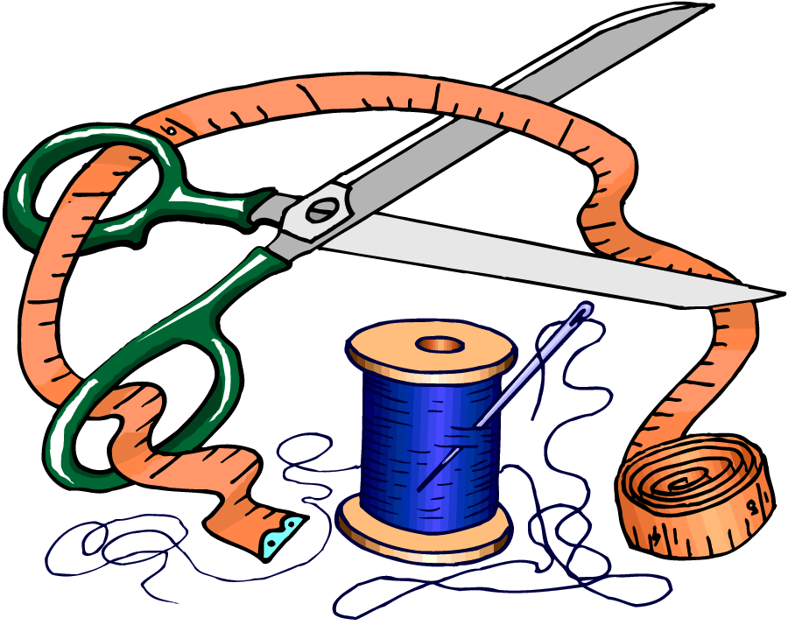

**Before we can start sewing on fabric or begin our pillows, we need to learn some basic information first.**

**Page 1: Sewing Supplies**

**Page 2: Safety First**

**Page 3: Parts of the Sewing Machine**

**Page 4: How to Thread Your Machine**

**Page 5: Straight Stitching on Paper**

**Page 6: Pivot and Measuring on Paper Directions**

**Page 7: Sewing Sample Directions**

**Sewing Supplies and Equipment**

**Sewing Machine Needle Bobbin**

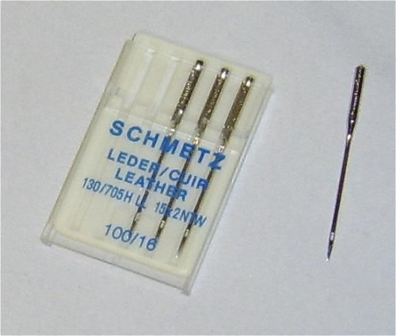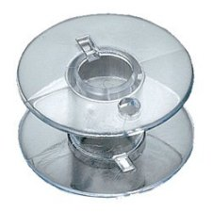

**Seam Ripper Pins**

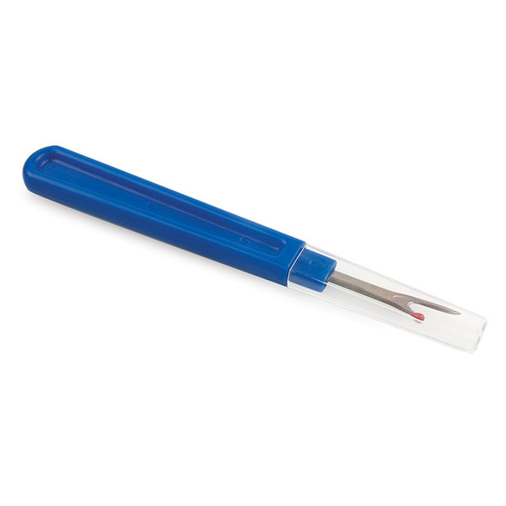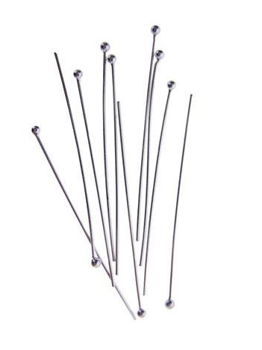

**Sewing Shears Spool of Thread**

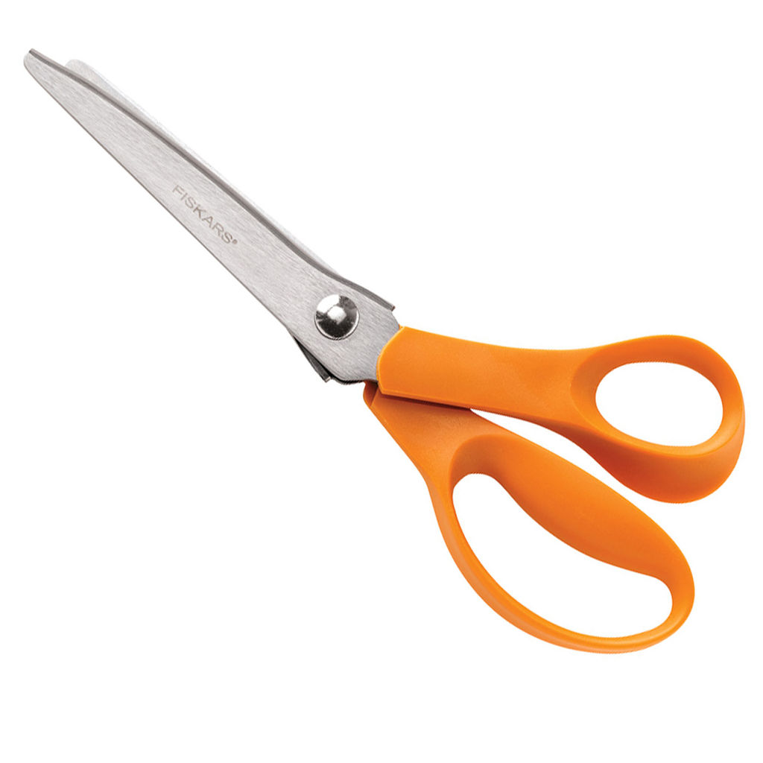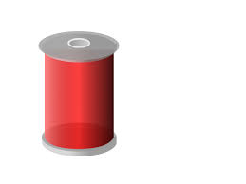

**Hand Sewing Needle Bobbin Case**

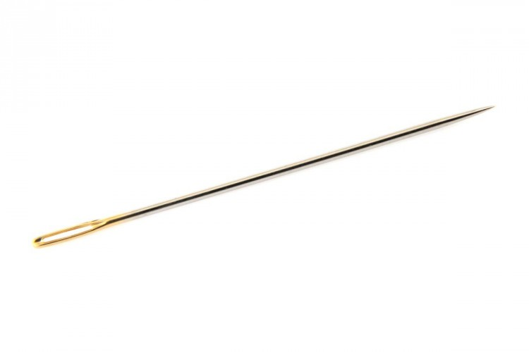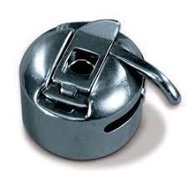

**Pin Holder Sewing Machine**

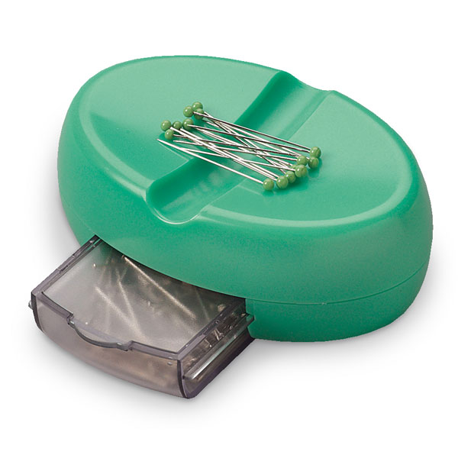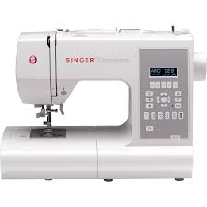

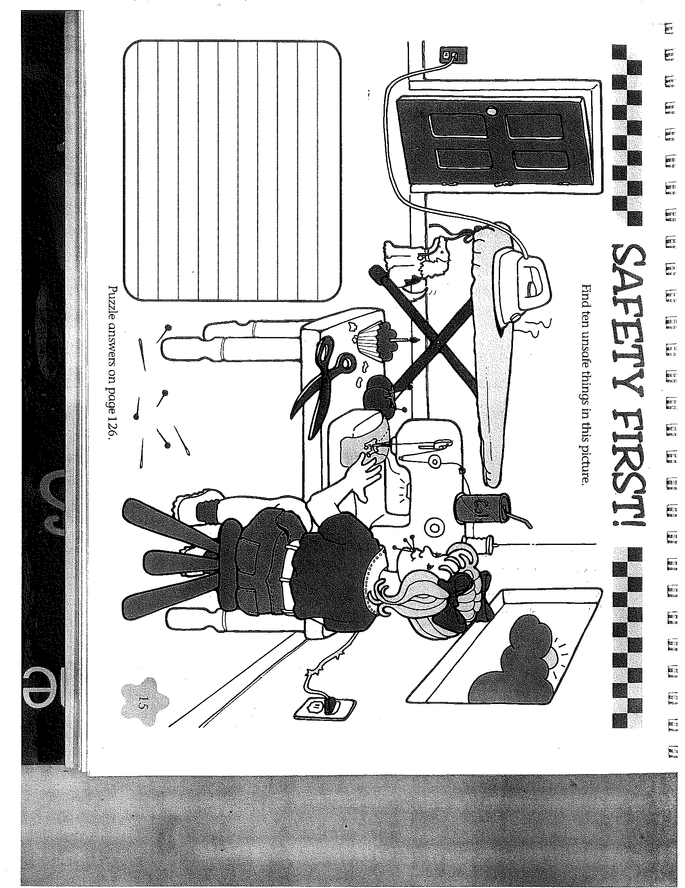

Sewing Machine Parts

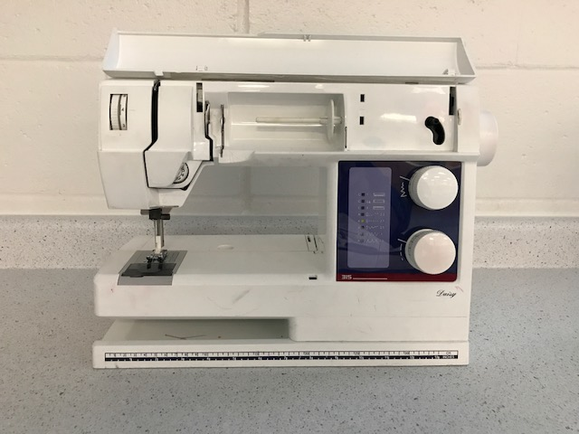

**Label the machine above with the correct parts. Then fill in the table below with notes about what those parts are used for.**

|  |  |
| --- | --- |
| **Parts of Machine** | **What is it used for?** |
| **DOOR** |  |
| **SPOOL HOLDER** |  |
| **SPOOL PINS** |  |
| **THREAD GUIDE** |  |
| **HAND WHEEL** |  |
| **THREAD TAKE UP** |  |
| **SEWING MACHINE NEEDLE** |  |
| **PRESSER FOOT** |  |
| **PRESSER FOOT LIFTER** |  |
| **STITCH WIDTH DIAL** |  |
| **REVERSE DIAL** |  |

**How to Thread Your Machine?**

**What you need:**

**Sewing Machine**

**Spool of Thread**

**Bobbin**

**Scissors**

**Patience ☺**

**Follow the QR code below to access the threading your machine video! As soon as you have your machine threaded (thread and bobbin) raise your hand and your teacher will check to make sure it is correct! Then keep practicing!**



**Straight Stitching on Paper**

**What you need:**

**Sewing Machine**

**Straight Stitching Paper**

**Patience ☺**

**Follow the QR code below to access the straight stitching on paper video. The teacher will also demonstrate what to do in class. Please remember this is NOT a race. It takes practice and patience to get a feel for your machine. ALSO…No snapping that presser foot lifter! Rip out the straight stitching paper from your packet and get started after you have watched the video and your teacher.**



**Practice Straight Stitching Sheet**

**You need to get 4 perfectly straight lines below. Put a star next to the four you want the teacher to check. Only show the teacher after you get 4! Don’t worry…practice makes perfect! Start at the top and work your way all the way down to the bottom of the line.**

|  |  |  |  |  |  |  |  |  |  |  |
| --- | --- | --- | --- | --- | --- | --- | --- | --- | --- | --- |
|  |  |  |  |  |  |  |  |  |  |  |

**Measuring and Pivot Stitching on Paper**

**What you need:**

**Sewing Machine**

**Piece of Colored Blank Paper**

**Ruler**

**Pencil**

**Directions:**

1. **Get a piece of colored paper, a ruler, and pencil.**
2. **With your ruler measure a 1.0 cm box in each corner. (see teachers sample.) SHOW TEACHER**
3. **Make a 3 inch line 1.0 cm from the edge of the paper. Makes sure that line does not start at a corner. (see teachers sample) SHOW TEACHER**
4. **Starting at the edge of the 3 inch line sew around the paper, pivoting at each corner, until you get to the other end of the 3 inch line. You are NOT sewing over the 3 inch line. (see teacher sample) SHOW TEACHER.**

**Follow the QR code below to access the measuring and pivoting stitching on paper video. Please remember this is NOT a race. It takes practice and patience to get a feel for your machine. Measuring and pivoting is an important part of your sewing project. REMEMBER…No snapping that presser foot lifter!**



Sewing Sample Directions

1. Take 2 pieces of fabric approximately 3 inches by 4 inches (it does not have to be exact). Both pieces should be the same size. Lay them on top of each other.
2. Pin both pieces of fabric together along one edge.
   1. Use about 4 pins to pin the top, middle, and bottom

(anytime you see a black triangle that indicates

where a pin should go.)

* 1. Place pins across the area to be stitched.



1. Stitch a ¼ inch or 1.0 cm seam.
   1. Use normal stitch length of 2.5
   2. Backstitch at the beginning and end of seam
   3. Cut off thread ends.
2. Press the seam open with a hot iron. Remember do NOT leave the iron laying down flat when you are finished.



1. Take a ruler and mark the ¼ inch or 1.0 cm from each corner, where they meet is where you are going to pivot.



1. Stitch ¼ inch or 1.0 cm from the edge of the fabric.
   1. Use stitch length 2.5
   2. Pivot where the corners intersect (just like on paper sample)
   3. Overlap stitches at the end to lock them in (about a ½ inch).
   4. Trim treads.



1. Staple your sample to this sheet. Make sure your first name, last name, and class period are on the front of the paper. Turn into teacher for a grade.